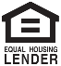 

**Name**   
Title   
NMLS #   
Address   
Phone   
Website

(Delete this and any logos that are not needed.)