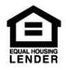Member-FDIC.jpg 

**Name**   
Title   
NMLS #   
Address   
Phone   
Website