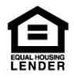Member-FDIC.jpg­ 

**Name**   
Title   
NMLS #   
Address   
Phone   
Website

(Note: You can delete unnecessary logos.)